
We have been alerted to a fraudulent app in the Apple App Store that mimics ParentPay branding.
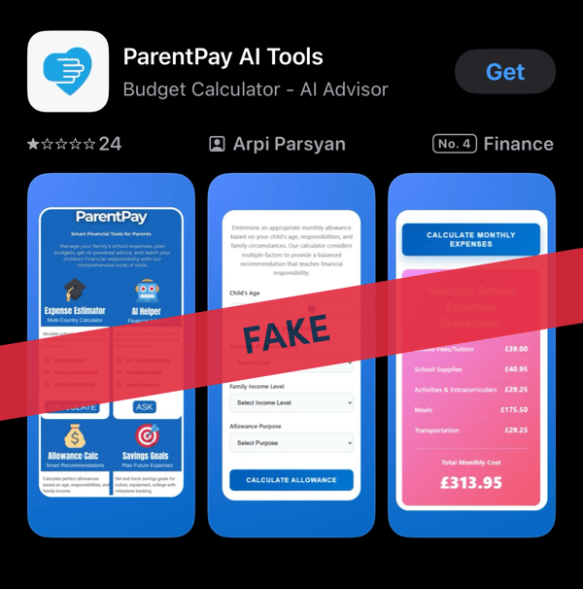
Security and safeguarding are top priorities at ParentPay Group, and we took swift action to report the app and are working closely with Apple to have it removed.

To date, we have recorded only 2 cases of affected parents.
Please be aware:

- ParentPay does not have an app available for download from any app stores

- To use ParentPay, parents should visit https://www.parentpay.com/ from a mobile phone or computer

- After logging in, parents can save a shortcut onto their phone’s home screen

This message is for awareness only, so you can confidently and quickly respond to any parent queries.

Yours sincerely,
ParentPay Group Customer Service Team

You are receiving this email because you work for a current customer or partner of ParentPay Group. We are contacting you regarding essential service or product information as per the terms of our contract. If you are not the correct person to receive these updates, please provide an alternative email address.
For more information on how we process your personal data, see our Privacy Notice.

Copyright ParentPay Group 2025
11 Kingsley Lodge, 13 New Cavendish Street, London, England, W1G 9UG
Company number: 13477997

