Sut mae gwneud brechdan.
Rhowch- place Taenwch- spread Bwytwch- eat Torrwch- cut bara- bread menyn- butter

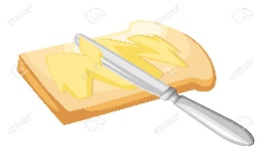 1) __________________________________

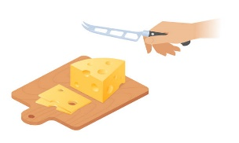2) _________________________________

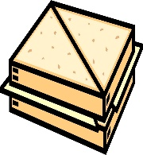 3) ____________________________________

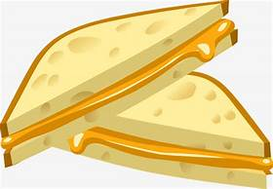 4) _____________________________

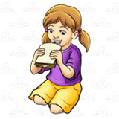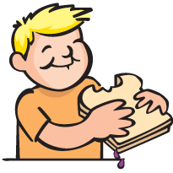 5) _____________________________

