Defnyddio ‘Teams’ / Using ‘Teams’

Mae wedi dod at ein sylw fod rhai ohonoch yn cael trafferth gyda ‘Teams’ o adref. Dyma ganllawiau syml i’ch helpu.

Wrth weithio yn eich ffeil, dyma’r camau i’w ddilyn;
1 – Dewiswch ffeil pwnc e.e. ‘English’, yna cliciwch ar ei enw.
2 – Dewiswch dasg hoffwch weithio arno, yna cliciwch ar ei enw.
3 – Ar y ‘task bar’ cliciwch ar y tri smotyn a dewiswch yr opsiwn ‘Open in browser’.Bydd hyn yn caniatáu chi i weithio ar y ddogfen.

Opsiwn arall yw agor dogfen newydd i gwblhau’r dasg, dyma’r camau i’w ddilyn;
1 - Dewiswch ffeil pwnc e.e. ‘English’, yna cliciwch ar ei enw.
2 – Ar y ‘task bar’ cliciwch ‘+New’, a dewiswch ‘Word document’. Bydd hyn yn caniatáu chi i gwblhau’r gwaith ar ddogfen newydd gan safio yn syth i’ch ffeil.
3 – Cofiwch ar ôl ei agor i enwi’r ddogfen gydag enw pwrpasol e.e ‘How I Feel’.

Os ydych dal yn cael trafferth i weithio ar lein, mae croeso i chi brintio’r taflenni gwaith i ffwrdd i weithio arnynt, ac yna tynnu llun o’r gwaith a’i anfon trwy e-bost.

It has come to our attention that some of you are having difficulty with ‘Teams’ at home. Here are some guidelines to help you.

When working in your file, these are the steps to follow;
1 - Choose a subject for example English, click on file name.
2 - Choose the task, which you wish to work on, again click on file name.
3 - On the task bar click on the three dots and choose ‘Open in browser’. This will allow you to edit the worksheet.

Another option is to open a new document to complete the work; these are the steps to follow;
1 - Choose a subject for example English, click on file name.
2 - On the task bar click +New, and choose 'Word document'. This will allow you to complete the work and will automatically save in your file.
3 – Remember to name the file purposefully once you have opened it for example ‘How I feel’.

If you are still having issues with working online following this, you are welcome to print off the worksheets to work on, and then take a picture of the work and send it via email.

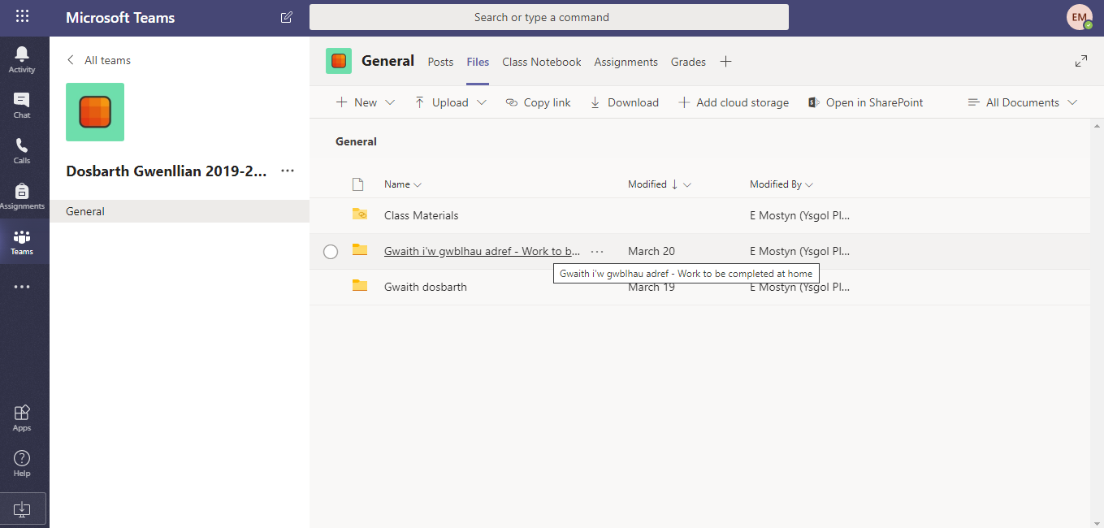
Cam 1

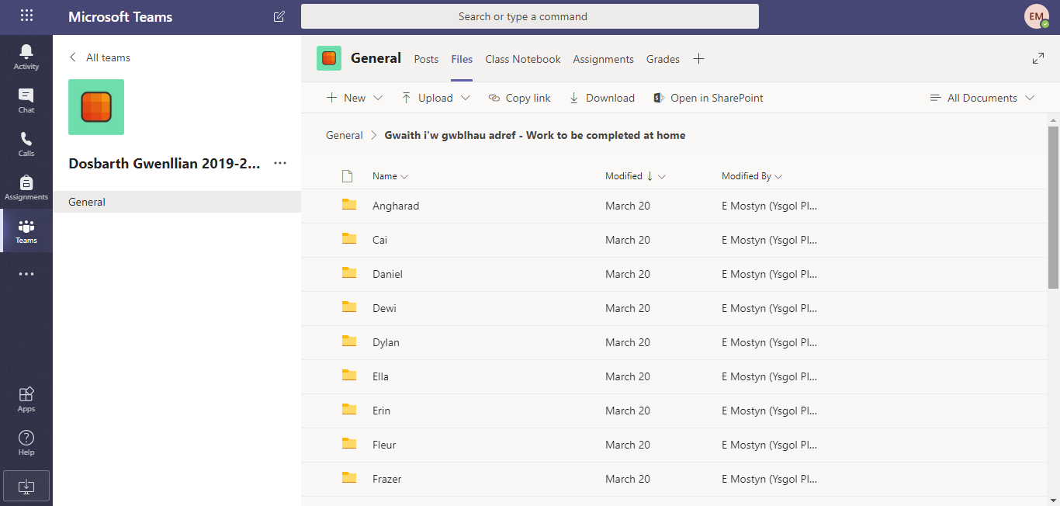
Cam 2

Cam 3
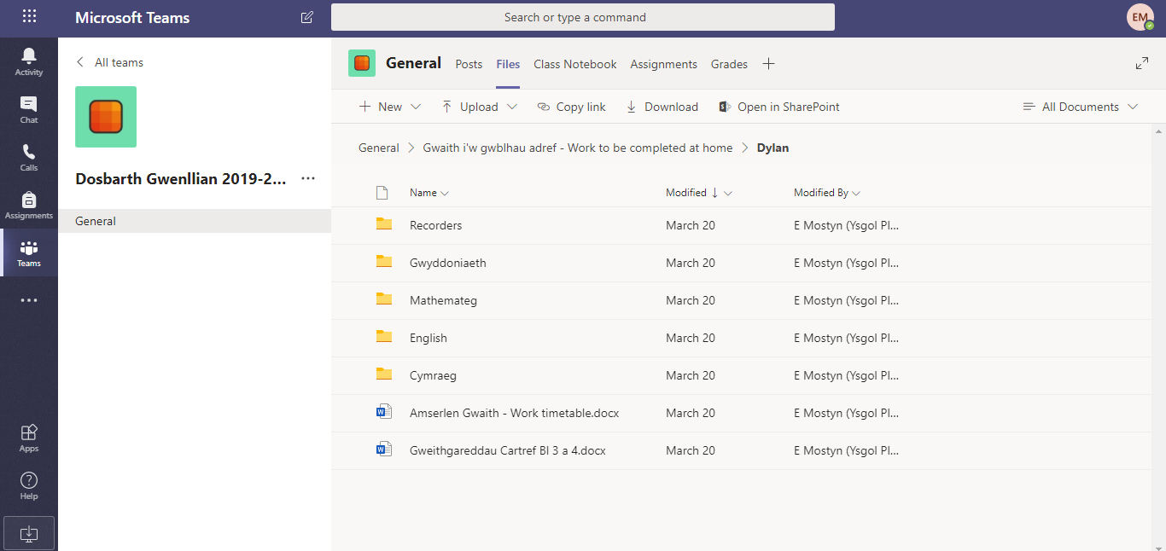

Cam 4
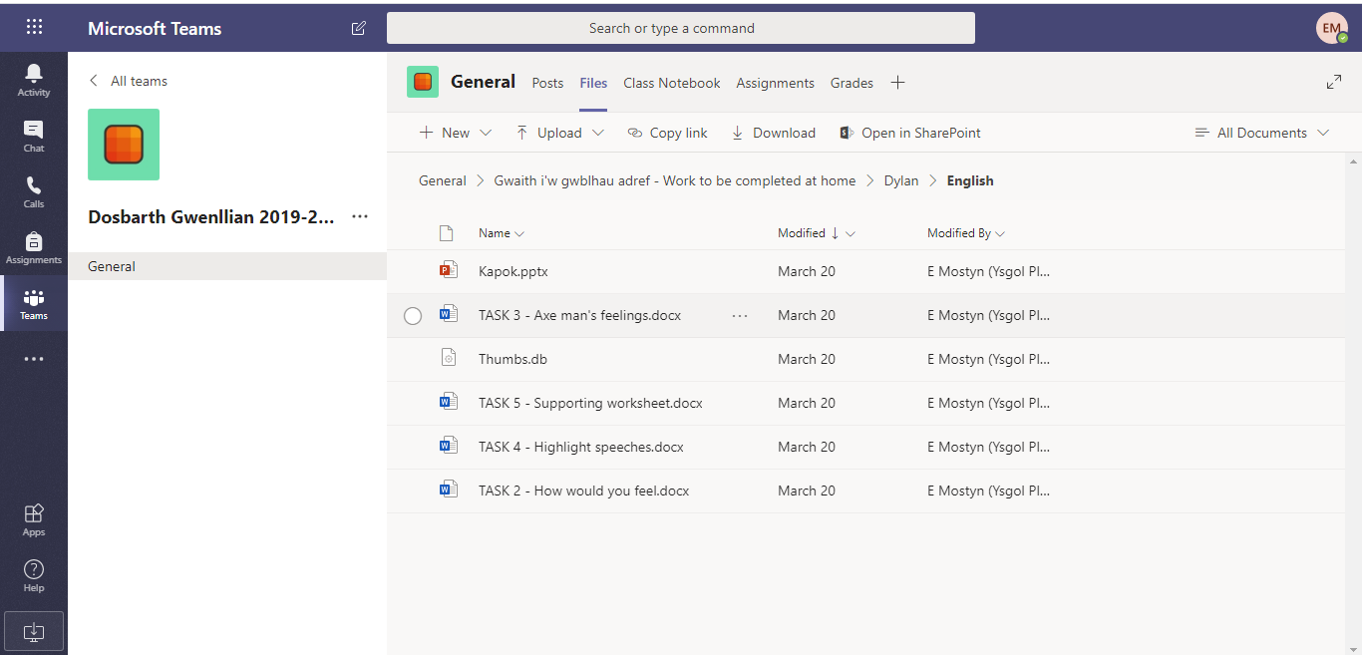

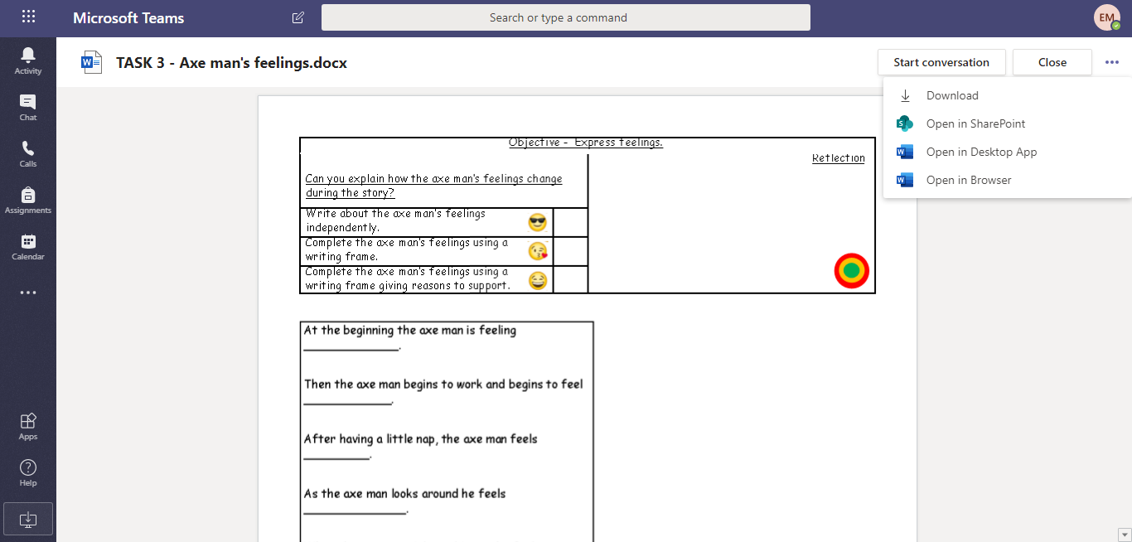
Cam 5

