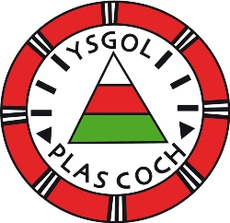
Dosbarth Erddig a Bers

Dear Parents/Guardians,
Reception class will have the opportunity to attend Christmas club this year. Christmas craft activities will be held weekly on the following dates:
Thursday November 28th – Dosbarth Erddig
Thursday December 5th – Dosbarth Bers
Thursdsy December 12th – Dosbarth Erddig
Thursday December 19th – Dosbarth Bers
The clubs will run from 3:30pm until 4:30pm. You will collect your child/children at 4:30pm from the main reception. Please let us know if you wish for your child to attend after school club from 4:30pm onwards.

If you wish for your child/children to attend the clubs. Please fill in and return the permission slip below by Monday 25th November.
Diolch yn fawr Miss E Jones

----------------------------------------------------------------

Child’s name__________________Class___________________

I give permission for my child to attend Christmas club with Miss Jones

Signature________________

