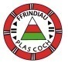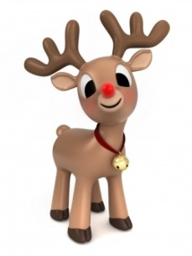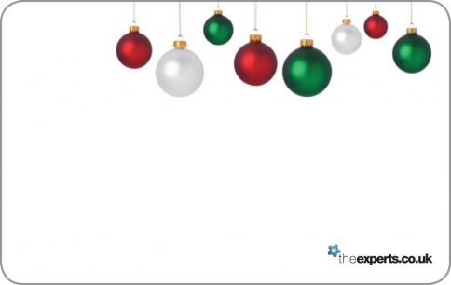

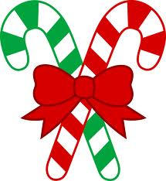

**Carolau**

**Groto Sion Corn**

**Lluniaeth**

**Stondinau Nadolig**

**Raffl**

**Tatws Gliter**

**Peintio Wynebau**

**Tombola**

**Stondin Deganau**

**Ynghyd a llawer**

**mwy**

**3.30-**

**6.00yh**

**3.30-**

**6.00pm**

**Dydd Mawrth 20fed o Dachwedd**

**Tuesday 20th November**

**Wedi ei drefnu gan rieni a ffrindiau Ysgol Plas Coch. Arian yn mynd tuag at cronfa yr ysgol**

**Organised by the friends of Ysgol Plas Coch. All proceeds in aid of the school.**

**Carols**

**Santa’s Grotto**

**Refreshments**

**Christmas Stalls**

**Raffle**

**Glitter Tattoos**

**Face Painting**

**Tombola**

**Toys stall**

**Plus much more**

**Ffair Nadolig**

**YSGOL PLAS COCH**