[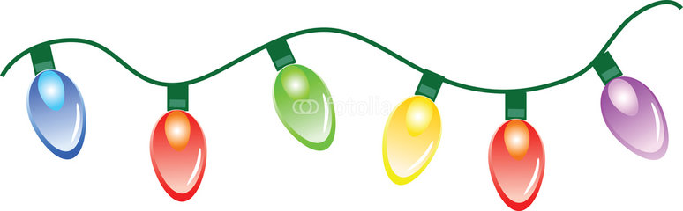](https://www.google.co.uk/url?sa=i&rct=j&q=&esrc=s&source=images&cd=&cad=rja&uact=8&ved=0ahUKEwicrbae8IbYAhVMWxQKHQuPAEsQjRwIBw&url=http://downloadclipart.org/f/christmas-fairy-lights-clip-art-761&psig=AOvVaw24d3AtdSMnGzoDZa5OF-FR&ust=1513250665900655)

**Meithrin & Derbyn: 5-6yh/pm\***

**\*(Gwarcheidwaid yn angenrheidiol/Guardians must attend)**

**Bl 1, 2 & 3: 6-7yh/pm**

**Bl 4, 5 & 6: 7-8yh/pm**

**Disgo Nadolig**

**Christmas Disco**

**Dydd Mawrth, 18 fed o Ragfyr**

**Tuesday 18th December**



*£1.50 y plentyn gan gynnwys diod*. *Tatŵs glitter, peintio gwyneb, "glow sticks", fferins a dip lwcus ar gael*

*£1.50 per child inc. drink. Glitter tattoos, face-painting, glowsticks, pick-a-mix and Lucky dip also available*